Covid-19 Secure YFC

Social Distancing measures for YFC activities
Updated 14 April 2021
Wales

Templates to assist YFC clubs open in a Covid secure way

-----------------------------------------------------------------------------------------

Agenda for club committee meeting – to make plans for restarting club activities that are Covid-secure

Template agenda for a club committee meeting to make plans for restarting club activities that are Covid-secure

Name of YFC club

Committee meeting agenda

- Welcome and chairs opening remarks

- Apologies for absence

- Review & approve the minutes of the previous committee meeting

- Matters arising from the minutes

- Correspondence received

Covid-secure YFC
- Background
  - Government plans - Moving to alert level three in Wales

  - From 27 March:

• Stay local requirement lifted

• First phased opening of tourism sector as self-contained accommodation opens

• Outdoor children’s activities open – this is for U18s and YFC organised activities for U18 YFC members can be planned

• Limited opening of outdoor areas of some historic places and gardens

• Libraries re-open

  - From 12 April (if conditions allow):

• Return to schools, colleges and other education

• All shops to open

• Close contact services to open

  - From 26 April - If public health conditions permit, the following relaxations can go ahead:

• Outdoor hospitality can open

• Organised outdoor activities will be permitted for up to 30 people

• Outdoor wedding receptions will be permitted for up to 30 people

• Outdoor visitor attractions can open

  - Covid-secure – the basics
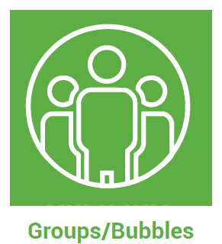
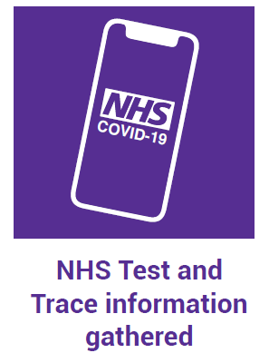

- What activities would members of our club like to do?
  - Can our club deliver these activities within the Covid-secure rules?
  - Do we (the committee) have the capacity (time, knowledge and skills) to plan these activities, supervise them and write the management plan using the templates provided?
Capacity - Does the committee feel confident to take responsibility to plan and supervise Covid-19 secure activities. If not, what can the committee do to acquire confidence? Who else can help (past members for example or others – parish council, village hall committee etc)?
Capacity - The committee has the knowledge (the Covid secure guidance for YFCs booklet)
Capacity - Do members of the committee, leaders and advisory have the time to plan the activities, to supervise and lead them as well?
Financial capacity: Will the club budget accommodate any spending that may be required that is in addition to the usual club activity spends? (For example, increased venue hire charges, venue cleaning, hand santiser, face coverings)

- How will the club committee manage:-
  - Social distancing
  - Face coverings
  - Groups (bubble)
  - Covid-secure venues (outdoors & later indoors)
  - Outside activities
  - Travel – to/from activities
  - Managing the risks
  - Including everyone (esp those who are at higher risk from Covid-19
  - Safeguarding arrangements (supervising by safely recruited (referenced & DBS checked supervisors, leaders or committee members)
  - Is the club recommending supervisors and leaders make use of Rapid Lateral Flow tests
  - Track & Trace requirements (template provided)
  - Who will supervise and lead (be responsible and accountable) for the activity on the day/evening?

- Writing up (using the templates provided):
  - Action plan record – who will write this up?
  - Covid-19 Risk Assessment, including safeguarding arrangements – who will prepare and write these up?
  - Adapting our existing activity risk assessments - who will adapt these and write these up?

- Communication with our club members before the event.
  - When all above plans are agreed and in place, write a communications notes to all YFC members, parents of those under 18 years of age as detailed in section 20 of the Covid-secure guidance for YFCs.
  - Who will prepare this?

- Date of next committee meeting

- Any other relevant business

- Meeting close

